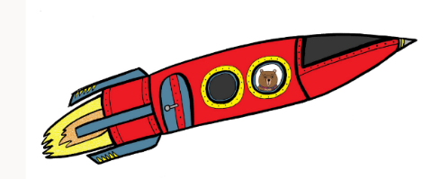

**Moving on to P1 with Edinburgh Bear**

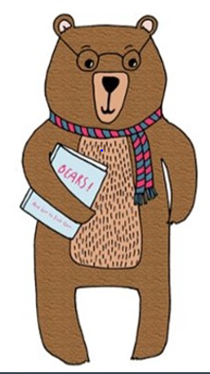

**Transition Information for Parents and Carers**

Transition is what we call it when a child moves from one thing to another.

There are lots of little transitions during the day – getting dressed, turning the television off, putting jackets on to go outside, all parents know that some transitions are easier than others!

Other transitions are bigger, for example starting a new nursery or school. All children need help to prepare for transitions.

In Edinburgh, all Early Years settings and primary schools are working together on one big project using Julia Donaldson’s book, **‘The Smeds and The Smoos’**.

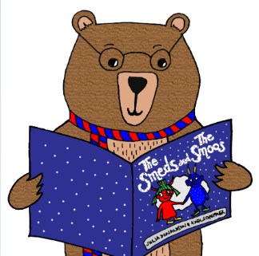This means that no matter what nursery they are enrolled in, or what primary school they move into, all children will be familiar with the same story and will have shared experiences. Research shows that shared experiences are one of the ways that we can support children during times of transition.

Your child would normally have started their transition into primary school this summer term. Due to the current restrictions the activities that your child would have taken part in have had to change. Primary Schools will contact everyone directly with more information about each child’s new school later in the summer.

Your child’s nursery will be offering lots of exciting experiences based on the story in the summer term. There will also be a transition SWAY on the CEC website <https://www.edinburgh.gov.uk/nurseries-childcare/play-learn-home-edinburgh-bear/1> where we will share ideas based around the story of **‘The Smeds and The Smoos’.** You can try these out with your child during the holidays, to help them to feel positive about the move into school. None of the activities suggested are intended to be stressful or time consuming. We hope they are things that might already fit into your daily routine.

The really important thing to remember for all parents is that what you are already doing with your children at home IS supporting their learning. Research shows us that in the Early Years children learn best through real life experiences, like helping sort the washing, preparing meals and just talking.

**P1 Learning starts with play**

Primary schools across Edinburgh are working hard to ensure that all children will have the best start to primary 1. Your child’s P1 classroom will have lots of opportunities for play and learning. The most important thing at the start will be making sure that everyone feels welcomed and finds something they enjoy at school.

Teachers and staff in schools are very aware of what a difficult time this has been for families. Your child will be supported and encouraged into their new class, with lots of chances to build relationships, make friends and play to learn.